FINAL PROJECT DOCUMENTATION
NAME | JUAN DELA CRUZ
PROJECT TITLE | ABC Centralized Accounting System
SUBJECT:  CODE:  TIME: | IT15/L Integrative Programming and Technologies
TOPIC (Type of Business Process) | #9 Accounting Systems
Products/Services | Accounting Firm
Website/Deployed (Link)
API/ALGO/MODEL: | Ex. SAP, PayMongo API, K-Nearest Neighbors (KNN)- ML Algo, etc.
Security Features | Ex. Authentication and Authorization, Input Validation, Logging and Monitoring etc.
Target user/s: | Ex. Employees, HR etc.
Subs System / Management Transaction/Modules | 1.Employees Registration Modules  2.Time and Attendance Monitoring Modules  3.Payroll Modules  4. Human Resources Modules  5.Accounting Modules
LOGO | 
Project Objectives: | Clearly state the objectives of the project. What specific goals or outcomes are you aiming to achieve with the system application? At least 3 to 5 objectives
Project Description: | -Describe the target project, audience, or users of the application and their requirements or expectations.  -Discuss the potential impact of the application on its users, organizations, or the broader community.  -Provide an overview of the technology stack or tools that will be used to develop the system application. This may include programming languages, frameworks, databases, and other software components.  -Briefly explain why these technologies were chosen and how they align with the project requirements.
Type of Users/ Role-Based Access | Ex.  1. System Administrator (Admin)  Username:  Password:  2. Manager / Supervisor  Username:  Password:  3. Employee  Username:  Password:
Use Case Diagram  (Role-Based Access) | 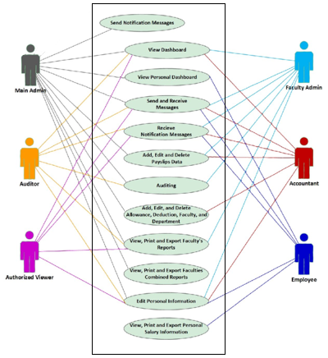  sample image
Data Dictionary | ABC Employees Monitoring Management System  FOLLOW THIS FORMAT  Users table  Field Names Datatype Length Description  UserID-PK Int-AI 9 User’s ID Number  Name Text 50 User’s Full Name  Role Text 25 User’s Role/Function  UserName Text 25 User’s Name or email  Password Text 25 User’s Password  Employees Registration table  Field Names Datatype Length Description  EmpID-PK Int-AI 9 Employees ’s ID Number  UserID-FK Int 9 User’s ID Number  EmpNumber Text 25 Employees ’s Company Number  LastName Text 20 Employees ’s Last Name  FirstName Text 30 Employees ’s First Name  MiddleName Text 20 Employees ’s Middle Name
Entity Relational Diagram (ERD)

Prototype (Frontend) | SCREENSHOTS AND DESCRIPTION  - Each prototype screen must include a clear screenshot – ALL Transactions.  - Add a label name to each image.  Provide a brief description for each screen to guide users on its functionality and how to interact with it.
Prototype (Backend) | SCREENSHOTS AND DESCRIPTION (Source Code)  - Each prototype screen must include a clear screenshot.  - Add a label name to each image.  API/Algo Usage: Mention the APIs/Algos used and their specific role in the showcased functionality.
API FUNCTIONS/  FEATURES | SCREENSHOTS AND DESCRIPTION (Source Code)  - Each prototype screen must include a clear screenshot.  - Add a label name to each image.  Discuss the process on how it works.
SECURITY FEATURES | SCREENSHOTS AND DESCRIPTION (Source Code)  - Each prototype screen must include a clear screenshot.  - Add a label name to each image.  Discuss the process on how it works.
Date Submitted:
Teacher’s Feedback | _________________________________________________________________  _________________________________________________________________  _________________________________________________________________  _________________________________________________________________  _________________________________________________________________  _________________________________________________________________  ________________________________ __________________________  Student’s Signature (after feedbacking) Teacher’s Signature

